Programming Collectibles

Before you start programming your collectibles, ensure you have a controller set up; this was covered in the previous tutorial.

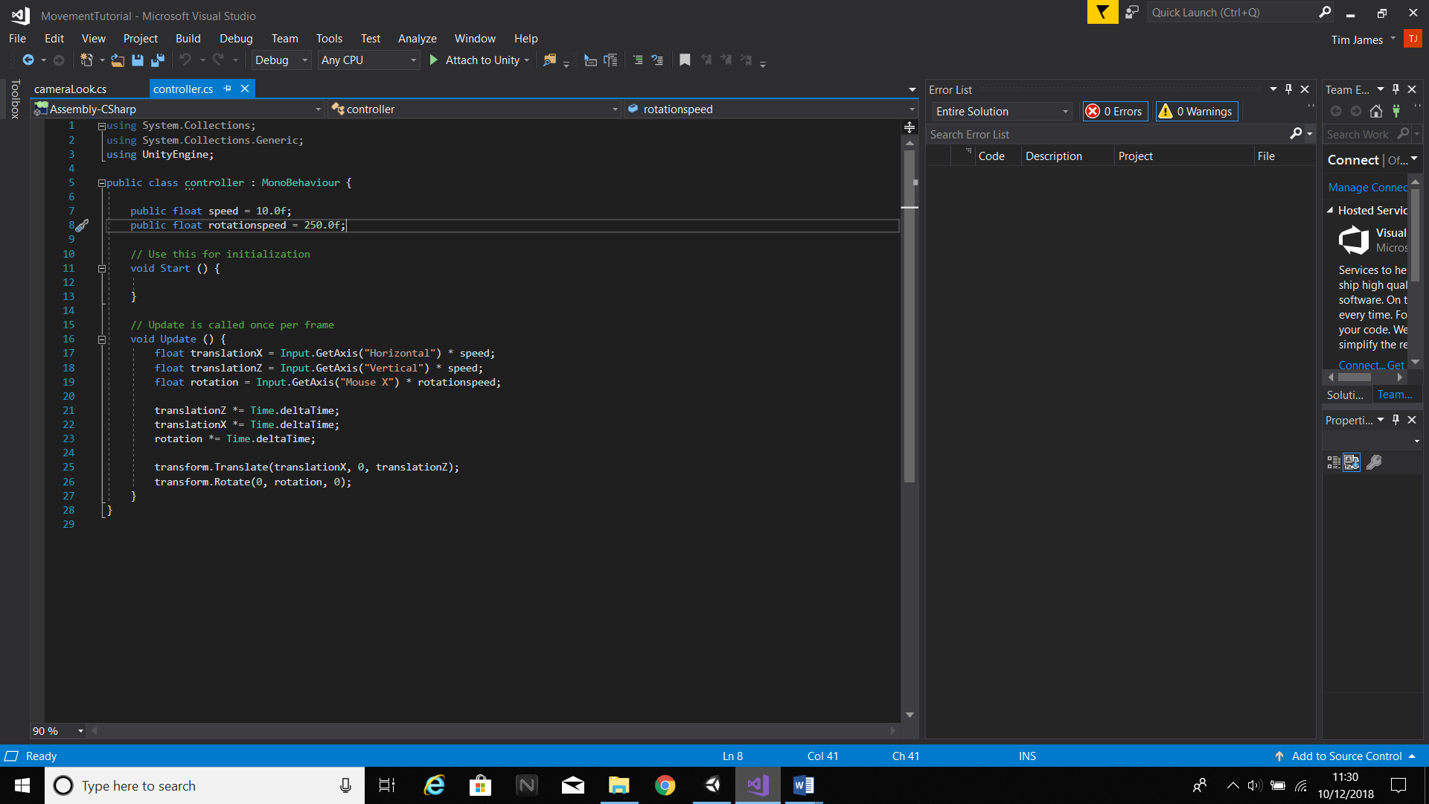

Now we make the collectible itself. Add a cylinder into the scene and transform it by the following values:

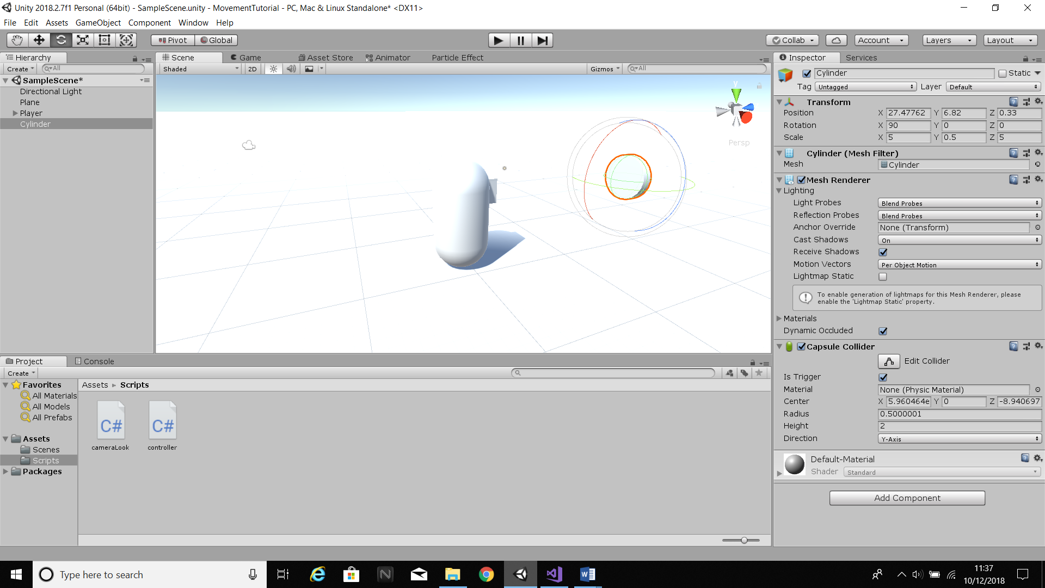

To ensure that the cylinder is collectible, set its collider to a trigger. Now to give it some effects, add a halo component to it and set the halo to a yellow colour. Then apply a script to it and call the script, “coinRotate”. In this script, write the following:

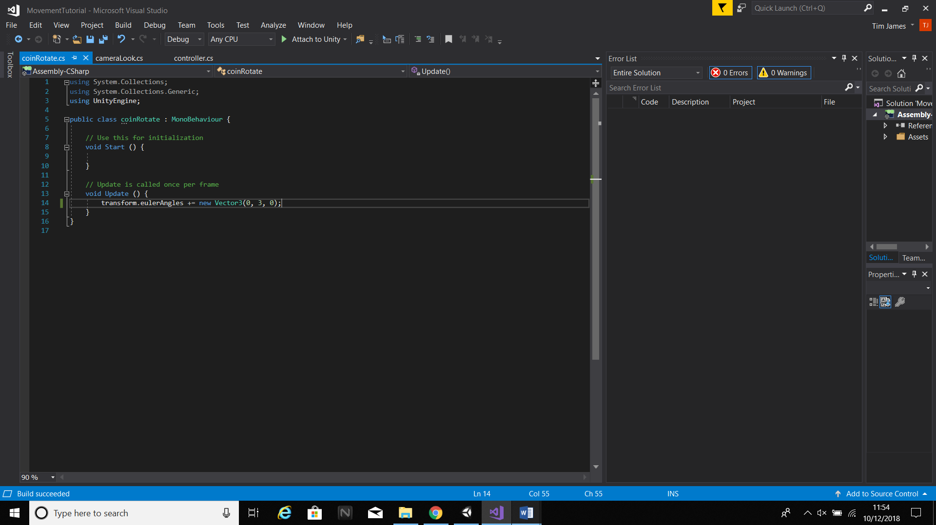

This ensures that the coin is constantly rotating on its Y-axis, and is all the scripting needed for the coin itself. The rest of the scripting is done in the controller. Before we continue, create a new tag called “coin” and add it to the coin. The inspector window for the coin should look something like this:

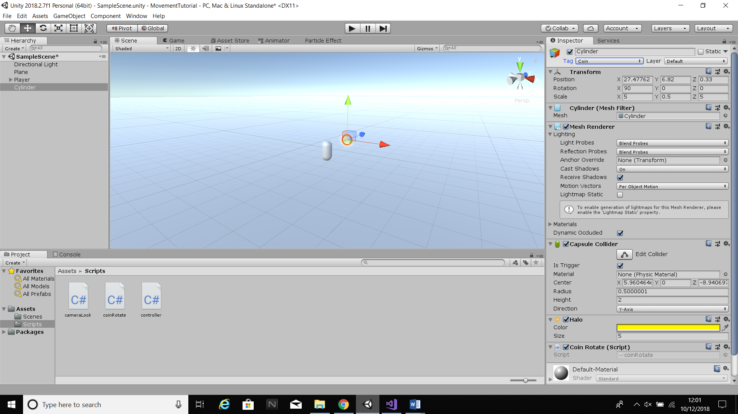

Now go into the controller script and create a new Void OnTriggerEnter and the collider will automatically set to other. We want to deactivate the object but first we need to ensure that it has the coin tag we set up earlier so the player doesn’t just destroy everything in their path. Create an “if” statement, and use the “compareTag” function.

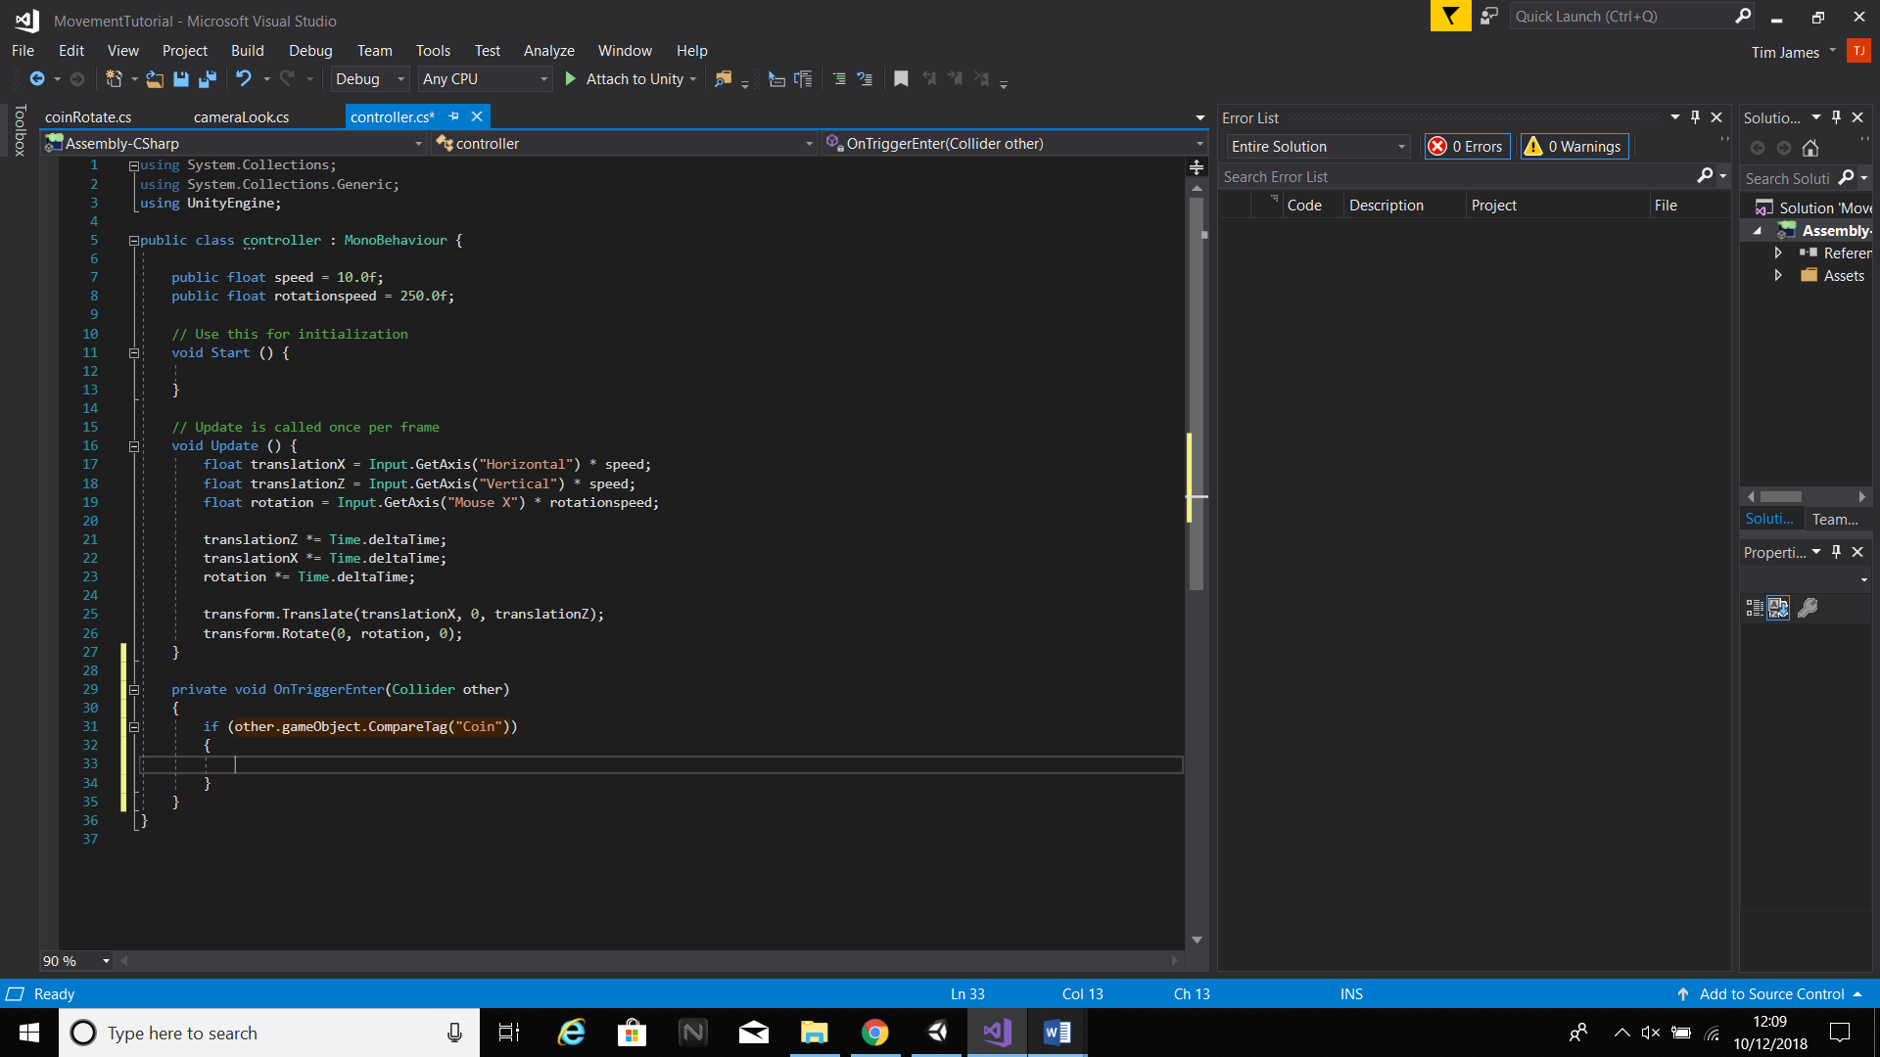

All that’s left is to deactivate the object. To do this, use SetActive(false). The finished script should look something like this:

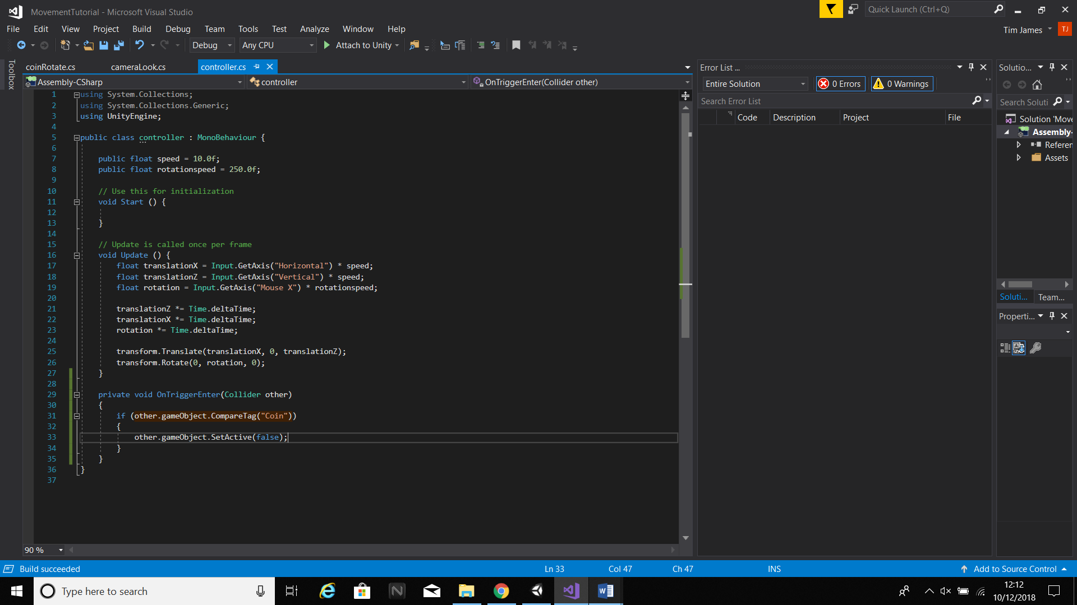

Make sure that the player has a rigidbody attached or the collectible function will not work.